Words Their Way
“Without knowing the force of words, it is impossible to know more.” ― Confucius
WW Groups  Red Group  Test day and work packet  due MONDAYS  Blue Group  Test day and work packet  due TUESDAYS  Green Group  Test day and work packet  due WEDNESDAYS  Yellow Group  Test day and work packet  due THURSDAYS  Orange Group  Test day and work packet  due FRIDAYS | 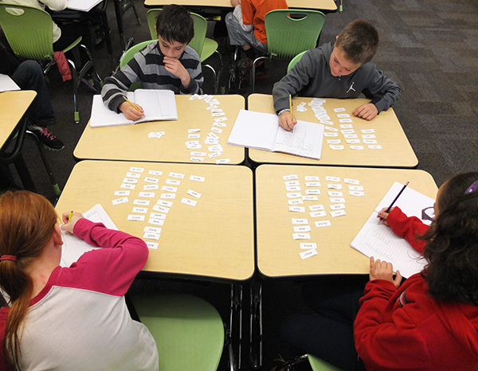  Words Their Way  -–Word Study Program  The Royal Oak School District has adopted the Words Their Way  program for all elementary students. This program provides a  format for pretesting students and providing developmentally  appropriately sets of words to study and learn spelling patterns  For more information about this program, visit this link –  www.mypearsontraining.com/pdfs/TG_WTW_WordStudy.pdf

-Classroom Practice
Daily Activities
Students are engaged in word work activities every day of the week. Five differentiated groups rotate
through five different sorting and spelling tasks;

Day 1: Code Words - Write spelling words in the given code and analyze the code words for patterns.
Day 2: Money Words - Find the total value of spelling words by determining the value of each letter
(matched to a penny, nickel, dime or quarter) and adding them up.
Day 3: Word Search - Highlight each of the spelling words in the puzzle and sort them by the vowel/
consonant pattern of each word.
Day 4: Fancy Words- Students roll a dice and write their words in fancy letters.
Day 5: Test/New Words - Meet with the teacher to take a spelling test and learn about a new set of words.

-For our first week of Word Work, the class will stay together as one whole group and follow the RED
SCHEDULE so students can learn how each activity is completed as well as how groups are expected to
conduct themselves. The next week and from then on, students will follow the schedule of the
differentiated color group he/she has been assigned to based on an analyzed pretest.

Word Work Schedule

 | Red | Orange | Yellow | Green | Blue
Monday | Day 5  Assessment & New Sort | Day 1  Code Words | Day 2  Money Words | Day 3  Word Search | Day 4  Fancy Words
Tuesday | Day 1  Code Words | Day 2  Money Words | Day 3  Word Search | Day 4  Fancy Words | Day 5  Assessment & New Sort
Wednes-day | Day 2  Money Words | Day 3  Word Search | Day 4  Fancy Words | Day 5  Assessment & New Sort | Day 1  Code Words
Thursday | Day 3  Word Search | Day 4  Fancy Words | Day 5  Assessment & New Sort | Day 1  Code Words | Day 2  Money Words
Friday | Day 4  Fancy Words | Day 5  Assessment & New Sort | Day 1  Code Words | Day 2  Money Words | Day 3  Words Search
– Assessment
Pre-Assessment
Sometime in the first few weeks of school, students will be given a spelling pre-test. Pre-tests are
analyzed for student understanding of developmental spelling skills and concepts. Each student will then
be placed into a spelling group with students at a similar developmental level.
Weekly Tests
Each student group will meet with the teacher once each week (on their assigned day) to take a spelling
test on 20 of the words from the set of words they have practiced all week.
Overall Grades
Spelling grades are calculated from test scores, class work, and weekly homework packets (see Home
Connection). Each of these assignments/test are given equal weight.

